Custom Attributes
No system will perfectly match every situation of your daily practice. Most emails that we receive demand custom adaptations for specific markets. An example of such a specific setting is in a medical practice. There, the patient number (an anonymous ID) is a very important attribute in organizing information. Although DMX would be very useful in medical practice it would need to incorporate the patient number as an optional attribute for every entry in the system.
Rather than offering a fixed (like 5 or 10) number of ‘user defined’ attributes, DMX offers the possibility to extend endlessly by defining custom attributes. Custom attributes are:
- properties that can be set for each item (folder, file, hyperlink) in the document exchange
- backed up when a new version of a file is created
- emitted through the RSS feed of the module
- can be specified on a global (i.e. portal) level. The attribute will be visible across the portal
- can be specified on a ‘per folder’ basis
- can be optionally inherited by child folders
- can be limited to act only on particular types in the document exchange (e.g. images)
- can optionally load a custom control to do more advanced tasks
- have a localized title

Creating a custom attribute
Log in as administrator and select ‘Global Attributes’ from the Admin menu in DMX.
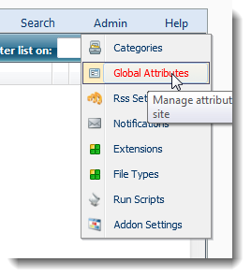
This will take you to the custom attributes screen:
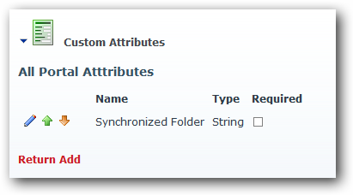
This is the list of attributes that are available throughout the portal. Let’s say we’d like to add a custom attribute for ‘Product’. Click ‘Add’ and fill in the fields:
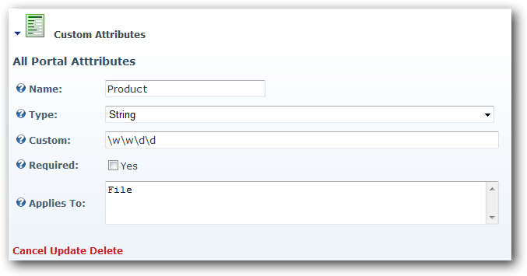

Name
Give the attribute a meaningful name (unique to your portal)

Type
The type can be String, Boolean (i.e. yes/no), Integer, Floating point, Date, Select, Custom. In the latter case we assume some other control will handle the data editing. In other cases DMX will create the UI for the editing.

Custom
In the case of a ‘String’ this can be a regular expression to test the string against. In the example above we have specified that the product code is two letters followed by two digits. Leave it empty if you don’t want to use regular expressions.
In the case of a ‘Select’ type you specify the selection here using a semi-colon separated list.

Required
Check if this is a mandatory field. Note this is irrelevant for some types (Boolean, Select)

Applies To
This is a semi-colon separated list of ‘Entry Types’ to which the custom attribute applies. Every entry (folder/file/hyperlink) in DMX has a type. This type can be found in the File Types screen or directly in SQL in the table DMX_Extensions (in the column ExtensionKey). A pdf is a type File.Adobe.Acrobat for instance. We can now specify for which types the attribute applies. So if we wanted it for images we might fill in ‘File.Jpg;File.Bmp;File.Gif;File.Tiff’. We can also group by using ‘File’ to specify all file types (i.e. not folders or hyperlinks) as we have done in the example above. Note that folders are of the type ‘Collection’ in DMX. Leaving this field blank means the attribute will show up for all entry types.
Now the new attribute should be visible when we try to add/edit a file in DMX:
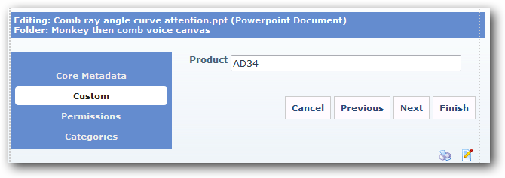
And it subsequently becomes visible in the details screen:
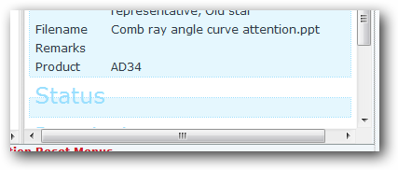

Defining per folder attributes
New since DMX 5.1 is the ability to add attributes per folder. You’ll find the menu button on the folder menu to edit this:
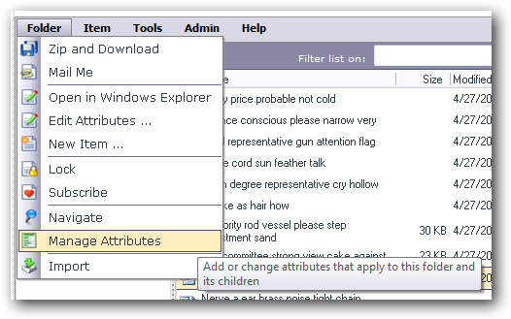
You’ll find a similar screen to the one before, except that it includes a new column ‘inherited’. Let’s add an attribute for the folder for ‘year’:
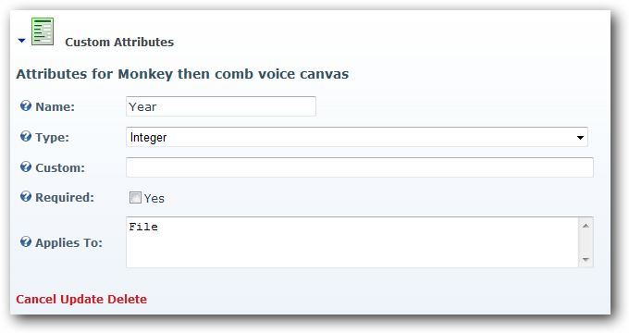
Clicking update should bring you to the list:
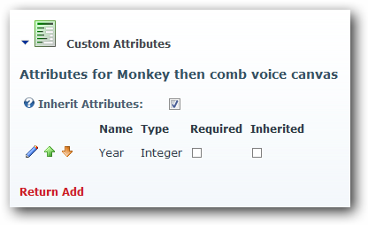

A note about inheritance
Now, the attribute is active from this folder down. If you edit the folder attributes on a folder further down you’ll find that the list includes this attribute with the ‘inherited’ box checked. This indicates that the attribute was defined further up the folder tree. You can break the inheritance by deselecting the checkbox ‘Inherit Attributes’ ABOVE the list. NOTE: This is not reversible!! Breaking the inheritance copies the attributes to new attributes. You can then opt to keep them or delete them. But you can’t inherit the old ones again.

A note about deleting attributes
When you delete an attribute, you delete all the stored values for this attribute with it. This is irreversible!!

